Probing interfacial water at submoleuclar level by scanning probe microscopy
Ying Jiang*
International Center for Quantum Materials, Peking University, Beijing, 100871, P. R. China
*yjiang@pku.edu.cn
Interfacial water is ubiquitous in nature and plays an essential role in a broad spectrum of physics, chemistry, biology, energy and material sciences. One of the most fundamental issues is the characterization of H-bonding configuration formed on surfaces and H-atom transfer through hydrogen bonds. Ideally, attacking this problem requires access to the internal degrees of freedom of water molecules, i.e. the directionality of OH bonds. However, it remains a great challenge due to the small size of hydrogen. In this talk, I will present our recent progress on the development of new-generation scanning probe microscopy/spectroscopy (SPM/S) with ultrahigh sensitivity and resolution, and its application to surface water. I will foucus on how to achieve submolecular-resolution imaging [1,2] and single-bond vibrational spectroscopy [3] of single water molecules via controlling tip-water coupling. Those technical advances provide us unprecedented opportunity to identify the topology of H-bonding configuration [4], track the proton dynamics [5], and assess quantitatively the nuclear quantum effects (NQEs) of H bond [3,5]. The submoleuclar-level studies of ion hydrates and two-dimensional ice structures will be also briefly introduced in the end.

References
- J. Guo, X. Z. Meng, J. Chen, J. B. Peng, J. M. Sheng, X. Z. Li, L. M. Xu, J. R. Shi, E. G. Wang*, Y. Jiang*, Nature Materials 13, 184 (2014).
- J. Peng, J. Guo, P. Hapala, D. Cao, R. Ma, B. Cheng, L. Xu, M. Ondráček, P. Jelínek*, E. G. Wang*, and Y. Jiang*, Nature Communications 9, 122 (2018).
- J. Guo, J.-T. Lü, Y. Feng, J. Chen, J. Peng, Z. Lin, X. Meng, Z. Wang, X.-Z. Li*, E.-G. Wang* and Y. Jiang*, Science 352, 321 (2016).
- J. Chen, J. Guo, X. Z. Meng, J. B. Peng, J. M. Sheng, L. M. Xu, Y. Jiang*, X. Z. Li*, E. G. Wang, Nature Communications 5, 4056 (2014).
- X. Meng, J. Guo, J. Peng, J. Chen, Z. Wang, J. R. Shi, X. Z. Li, E. G. Wang*, Y. Jiang*, Nature Physics, 11, 235 (2015).

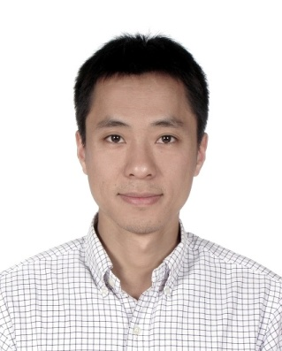
Biography
Ying Jiang received his Bachelor’s degree from Beijing Normal University in 2003 and his PhD from Institute of Physics, Chinese Academy of Sciences (CAS) in 2008. He was a visiting scientist at Forschungszentrum Jülich GmbH in Germany (2006-2007). After working as a Postdoctoral Associate at University of California, Irvine (2008-2010), he joined International Center for Quantum Materials, Peking University as a tenure-track assistant professor. He was promoted to associate professor with tenure in 2016 and full professor in 2018. He has published over 30 peer-reviewed papers, including 2 in Science and 6 in Nature Journals. He has delivered over 40 invited talks (including 5 plenary talks) in a number of international conferences. He was awarded Outstanding Young Scientist (2012), Cheung Kong Young Scholar (2016), Emerging Leader (IOP, 2016), Distinguished Young Scholars of NSFC (2017). His research works were selected as Top-ten Progresses of Science and Technology of China (2016) and Top-ten Progresses of Basic Research of China (2017). He is an expert in advanced scanning probe microscopy and spectroscopy. His current interests are focused on the atomic-scale properties and ultrafast dynamics in single molecules and low-dimensional materials.

